Problem: Cab Booking and Fleet Management System
A Cab Booking and Fleet Management System is required to manage the daily operations of a taxi service that connects customers with available drivers. Whenever a customer requests a ride, the system records information such as the booking identifier, customer details, pickup and drop locations, booking time, trip status, fare, the assigned cab, and the driver responsible for the trip. Since ride requests arrive continuously throughout the day, new bookings may need to be recorded at the beginning of the collection, appended at the end, or inserted immediately after an existing booking when requested by an operator. Likewise, bookings may be cancelled before the ride begins or removed once the trip has been completed. Customer information, assigned driver details, pickup location, drop location, fare, or trip status may also change while the booking remains active, requiring existing records to be updated efficiently without reorganizing the entire collection.
Customer service personnel frequently review booking records while responding to customer enquiries. They should therefore be able to move from one booking to the next, return to the previous booking, display all active bookings in either direction, locate a booking using its booking identifier, determine the total number of active bookings currently managed by the system, and retrieve all bookings belonging to a particular customer whenever requested. During busy periods, supervisors may also need to arrange active bookings according to booking time, customer name, or fare amount so that they can monitor pending requests, identify priority bookings, and allocate resources more effectively.
The system must also maintain information about every cab that is currently available for service. Each available cab is identified by its cab number and stores information such as the assigned driver, driver rating, current location, and availability status. Whenever a new booking is confirmed, the next available cab should be assigned in a fair manner so that all drivers receive ride requests as evenly as possible. Once a cab has been allocated, the reference used for allocation should automatically move to the following available cab, ensuring that repeated bookings are distributed across the fleet instead of repeatedly selecting the same vehicle. If a ride is cancelled or completed, the corresponding cab should immediately become available again and rejoin the allocation cycle without disturbing the order of the remaining available cabs. Fleet operators should also be able to introduce newly available cabs, temporarily remove unavailable cabs, locate a cab using either its cab number or driver identifier, arrange available cabs according to cab number or driver rating, and view every available cab exactly once by starting from the current allocation point and continuing until the complete allocation cycle has been traversed.
Whenever a trip is completed, its associated booking should no longer remain among the active bookings. Instead, it should be transferred to a separate collection that stores completed rides for future reference. The completed ride records should preserve the booking details, customer information, driver information, trip locations, booking time, completion status, and fare collected. Since these records are retained only for enquiry and reporting purposes, new completed rides should simply be added as they occur, while users should be able to search previous trips using either the booking identifier or customer identifier, display the complete ride history, and generate reports showing completed trips, cancelled bookings, occupied cabs, available cabs, and the total number of active bookings. The application should provide a menu-driven interface that supports Cab Management, Booking Management, Ride Allocation, Ride Completion and Cancellation, Search Operations, Sorting Operations, Display Operations, and Reports, while ensuring that all booking, cab, and ride history records remain accurate and consistent throughout the operation of the system.
1. Identify noun phrases and circle them on the document. This should be filtered and refined into conceptual classes and attributes. Tabulate conceptual classes and related noun phrases.
Conceptual Class | Related Noun Phrases | Attributes
Booking | Booking, Booking Identifier, Pickup Location, Drop Location, Booking Time, Trip Status, Fare, Assigned Cab, Assigned Driver | bookingId, bookingTime, pickupLocation, dropLocation, fare, tripStatus, customer, cab, driver
Customer | Customer, Customer Details, Customer Name | customerId, customerName, customerDetails
Driver | Driver, Driver Identifier, Driver Name, Driver Rating | driverId, driverName, driverRating
Cab | Cab, Cab Number, Current Location, Availability Status | cabNumber, currentLocation, availabilityStatus, assignedDriver
Ride History | Completed Ride, Ride History | completedRideList
Booking Management | Active Booking Collection | activeBookings
Cab Management | Fleet Management, Available Cab Collection, Allocation Point | availableCabs, allocationPointer
Report | Reports, Completed Trips, Cancelled Bookings, Occupied Cabs, Available Cabs | completedTrips, cancelledBookings, occupiedCabs, availableCabs, totalActiveBookings

2. Identify verb phrases and underline them on the document. This should be filtered and refined into methods of the classes. Tabulate methods and related verb phrases.
Conceptual Class | Related Verb Phrases | Methods
Booking | update customer information, update assigned driver, update pickup location, update drop location, update fare, update trip status | updateCustomer(), updateDriver(), updatePickupLocation(), updateDropLocation(), updateFare(), updateTripStatus()
Customer | request a ride, retrieve bookings | requestRide(), getBookings()
Driver | accept assigned trip, complete ride | acceptRide(), completeRide()
Cab | update current location, become available, become unavailable | updateLocation(), setAvailable(), setUnavailable()
RideHistory | transfer completed ride, search previous trips, display ride history | addCompletedRide(), searchRide(), displayRideHistory()
BookingManagement | record booking, insert at beginning, append at end, insert after existing booking, cancel booking, remove booking, locate booking, move to next booking, return to previous booking, display bookings, determine total bookings, retrieve bookings by customer, arrange bookings | addBooking(), insertAtBeginning(), insertAtEnd(), insertAfterBooking(), cancelBooking(), removeBooking(), searchBooking(), nextBooking(), previousBooking(), displayBookings(), countBookings(), getBookingsByCustomer(), sortBookings()
CabManagement | introduce new cab, remove unavailable cab, assign next available cab, move allocation reference, locate cab, arrange available cabs, view available cabs | addCab(), removeCab(), assignCab(), moveAllocationPointer(), searchCab(), sortCabs(), displayAvailableCabs()
Report | generate completed trips, generate cancelled bookings, generate occupied cabs, generate available cabs, generate total active bookings | generateCompletedTripsReport(), generateCancelledBookingsReport(), generateOccupiedCabsReport(), generateAvailableCabsReport(), generateActiveBookingsReport()

3. Draw the class diagram using the conceptual classes, attributes and methods. Show the interaction between objects and relationships between classes.
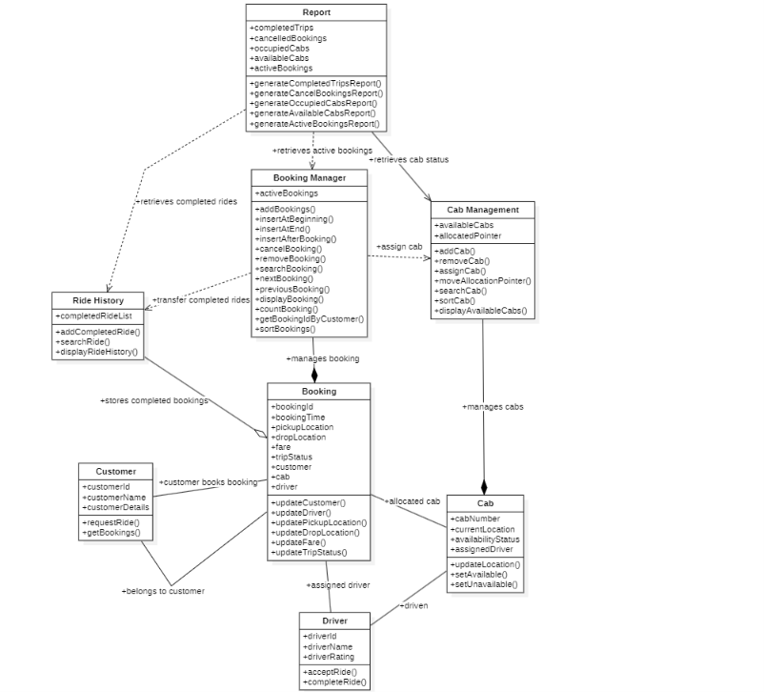
4.Write the operations of the data structure in Java. Specify the time complexity of operations.
1. Active Bookings (Doubly Linked List)
Reason: The system requires insertion at the beginning, end, and after a given booking, deletion, forward and backward traversal, and updates. A Doubly Linked List supports all these efficiently.
Operation | Java Method | Time Complexity
Insert at beginning | insertAtBeginning() | O(1)
Insert at end | insertAtEnd() | O(1) (using tail pointer)
Insert after a booking | insertAfterBooking() | O(n)
Delete booking | removeBooking() | O(n)
Cancel booking | cancelBooking() | O(n)
Search booking by ID | searchBooking() | O(n)
Update booking | updateBooking() | O(n)
Display forward | displayForward() | O(n)
Display backward | displayBackward() | O(n)
Count active bookings | countBookings() | O(n)
Retrieve bookings of customer | getBookingsByCustomer() | O(n)
Sort bookings | sortBookings() | O(n²) (Bubble Sort on Linked List)

2. Available Cabs (Circular Linked List)
Reason: The problem requires Round Robin allocation, where the allocation pointer continuously moves to the next available cab.
Operation | Java Method | Time Complexity
Add cab | addCab() | O(1)
Remove cab | removeCab() | O(n)
Assign next available cab | assignCab() | O(1)
Move allocation pointer | moveAllocationPointer() | O(1)
Search cab | searchCab() | O(n)
Sort cabs | sortCabs() | O(n²)
Display available cabs | displayAvailableCabs() | O(n)

3. Completed Ride History (Singly Linked List)
Reason: Completed rides are only stored for future reference and are never modified frequently.
Operation | Java Method | Time Complexity
Add completed ride | addCompletedRide() | O(1) (tail pointer)
Search by Booking ID | searchRide() | O(n)
Search by Customer ID | searchRideByCustomer() | O(n)
Display ride history | displayRideHistory() | O(n)

5.Write pseudocode for other entities showing composition of data structures. Specify the time complexity of the significant behaviours of the entities.
1. Booking Management
Data Structure: Doubly Linked List
addBooking()
BEGIN
Create new Booking node
IF booking list is empty
head ← new node
tail ← new node
ELSE
Insert node at end
Update previous and next links
ENDIF
END
Time Complexity: O(1) (using tail pointer)

searchBooking()
BEGIN
current ← head
WHILE current is not NULL
IF bookingId matches
RETURN booking
ENDIF
current ← current.next
ENDWHILE
RETURN Not Found
END
Time Complexity: O(n)

cancelBooking()
BEGIN
Search booking
IF found
Remove booking node
Make assigned cab available
ENDIF
END
Time Complexity: O(n)

displayBookings()
BEGIN
current ← head
WHILE current is not NULL
Display booking details
current ← current.next
ENDWHILE
END
Time Complexity: O(n)

sortBookings()
BEGIN
Repeat
Compare adjacent bookings
Swap if order is incorrect
Until no swaps occur
END
Time Complexity: O(n²)

2. Cab Management
Data Structure: Circular Linked List
addCab()
BEGIN
Create new Cab node
IF list is empty
head ← new node
new node points to itself
ELSE
Insert after tail
Make new node point to head
ENDIF
END
Time Complexity: O(1)

assignCab()
BEGIN
IF no cab available
RETURN No Cab
ENDIF
Assign current cab
Mark cab unavailable
Move allocation pointer to next available cab
RETURN assigned cab
END
Time Complexity: O(1)

removeCab()
BEGIN
Search cab
IF found
Remove cab from circular list
ENDIF
END
Time Complexity: O(n)

displayAvailableCabs()
BEGIN
current ← allocation pointer
DO
Display cab
current ← current.next
WHILE current ≠ allocation pointer
END
Time Complexity: O(n)

3. Ride History
Data Structure: Singly Linked List
addCompletedRide()
BEGIN
Create completed ride node
Insert at end
END
Time Complexity: O(1) (using tail pointer)

searchRide()
BEGIN
current ← head
WHILE current is not NULL
IF bookingId matches
RETURN ride
ENDIF
current ← current.next
ENDWHILE
RETURN Not Found
END
Time Complexity: O(n)

displayRideHistory()
BEGIN
current ← head
WHILE current is not NULL
Display ride details
current ← current.next
ENDWHILE
END
Time Complexity: O(n)

6.Implement the system using Java.
7.Test the system with test cases covering the upper-bound and lower-bound scenarios for every operation. Justify this. (Do this in a Word file and submit it with the program)

